- PRODUCT DESCRIPTION
A cinema booking website is an online platform that allows users to browse movie listings, select showtimes, and purchase tickets for cinema screenings. The website would typically have a user-friendly interface that allows users to search for movies by title, genre, date, and location.

Upon arriving at the website, users would first be prompted to select their location and preferred cinema. They would then be presented with a list of movies currently showing at that cinema, along with showtimes and available seats. Users would be able to choose the movie and showtime they want, select their preferred seating, and proceed to the checkout to purchase their tickets.

In addition to movie listings and ticket purchases, the website may also offer other features such as movie reviews, trailers, and information about upcoming releases. The website may also have a loyalty program that rewards frequent movie-goers with discounts or other perks. Overall, a cinema booking website is designed to make the process of buying movie tickets as convenient and hassle-free as possible for users.

- TEAM DESCRIPTION

Skills | Team Members
- Frontend Developer | Hossam Sabry
- Backend Developer | Ahmed Adel
- Intermediate in Documentation  - Amateur in Ai | Yousef Hady
- Know In UML Diagrams | Omar AboElabas
- Database Administrator | Abdelrahman Elshazly
- My Sql server  - Database Administrator | Waleed Mohamed

- SOFTWARE PROCESS MODEL DESCRIPTION
(agile)
Agile helps you to act systematically and with good knowledge of the business development framework, and provides you with tools and techniques that improve the performance of the team and the organization as a whole.
An agile gives you the ability to mix different approaches and even innovate new frameworks to maximize collaboration and innovation.
- PRODUCT DEFINITION
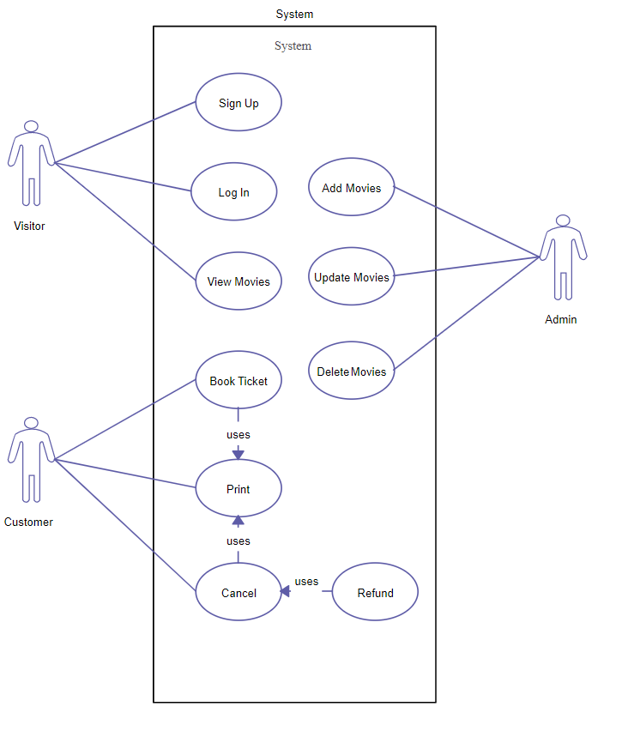

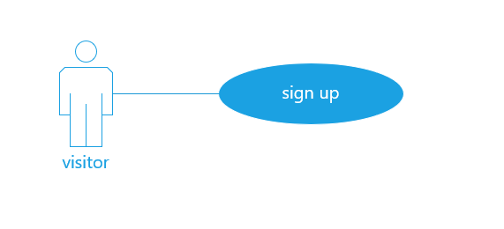

Use case name | Sign up
Unique ID | 001
Area | Website
Actor(s) | Visitor
Description | visitor creates account
Triggering Event | visitor click “sign up” button in the website
Preconditions | The visitor needs to open website on monitor
Post conditions | visitor has successfully created account
Assumptions | - visitor has browser  - A valid data
Steps Performed |  | Information for Steps
- Open website  - Click on “sign up ” button  - Validation of entered data by website |  | Step 3: Name, Username, Password, E-mail

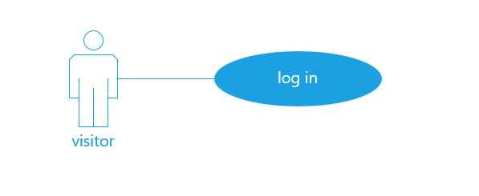
Use case name | Log in
Unique ID | 002
Area | Website
Actor(s) | Visitor
Description | visitor log in to his account
Triggering Event | visitor click “log in” button in the website
Preconditions | - The visitor needs to open website on monitor  - The visitor needs to have account
Post conditions | visitor has successfully logged in to his account
Assumptions | - visitor has browser  - A valid data
Steps Performed |  | Information for Steps
- Open website  - visitor enters his data  - Click on “Login” button  - Validation of entered data by website |  | Step 3: Name, Username, Password, E-mail

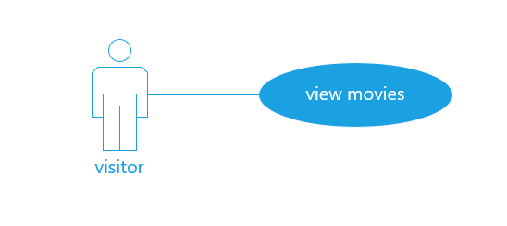
Use case name | View movies
Unique ID | 003
Area | Website
Actor(s) | Visitor
Description | visitor view movies
Triggering Event | visitor click “ movies ” button in the website
Preconditions | - The visitor needs to open website on monitor  - The visitor needs to have account
Post conditions | visitor has successfully select movie
Assumptions | - visitor has browser  - A valid data
Steps Performed |  | Information for Steps
- Open website
- Click on “movies” button
- View movies

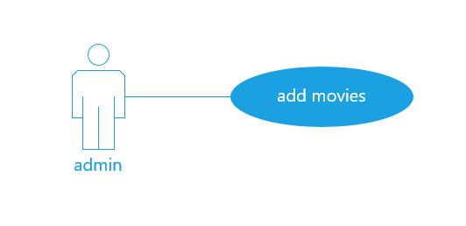
Use case name | Add movies
Unique ID | 004
Area | Website
Actor(s) | Admin
Description | Admin add movies
Triggering Event | The admin needs to login in to his account
Preconditions | - The visitor needs to open website on monitor  - The visitor needs to have account  - The admin needs to have access
Post conditions | visitor has successfully logged in to his account
Assumptions | - admin has browser  - A valid data
Steps Performed |  | Information for Steps
- Open website
- Admin log in
- Admin add new movies in a website

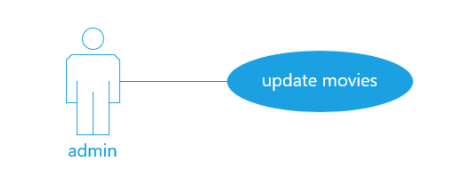
Use case name | Update movies
Unique ID | 005
Area | Website
Actor(s) | Admin
Description | Admin update movies
Triggering Event | admin click “ update ” button in the website
Preconditions | - The admin needs to open website on monitor  - The admin needs to have account  - The admin needs to have access
Post conditions | admin has successfully logged in to his account
Assumptions | - admin has browser  - A valid data
Steps Performed |  | Information for Steps
- Open website
- Admin log in
- Admin updates movies

Use case name | Delete movies
Unique ID | 006
Area | Website
Actor(s) | Admin
Description | Admin delete movies
Triggering Event | Admin click “delete” button in the website
Preconditions | - The visitor needs to open website on monitor  - The visitor needs to have account  - The admin needs to have access
Post conditions | film has successfully deleted
Assumptions | - admin has browser  - A valid data
Steps Performed |  | Information for Steps
- Open website
- Admin log in
- Admin delete movies
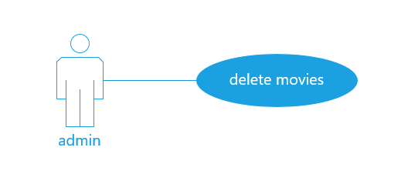

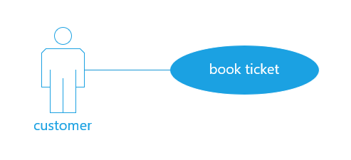
Use case name | Book ticket
Unique ID | 007
Area | Website
Actor(s) | Customer
Description | Customer book ticket
Triggering Event | customer click “book ticket” button in the website
Preconditions | - The customer needs to open website on monitor  - The customer needs to have account
Post conditions | visitor has successfully logged in to his account
Assumptions | - customer has browser  - A valid data
Steps Performed |  | Information for Steps
- Open website
- Customer log in
- Customer book ticket

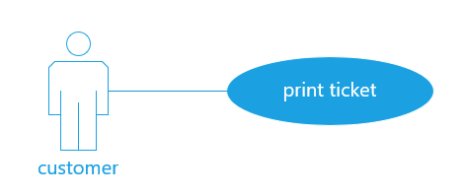

Use case name | Print ticket
Unique ID | 008
Area | Website
Actor(s) | Customer
Description | Customer print ticket
Triggering Event | customer click “print” button in the website
Preconditions | - The customer needs to open website on monitor  - The customer needs to have account
Post conditions | Ticket has successfully printed
Assumptions | - Customer has browser  - A valid data
Steps Performed |  | Information for Steps
- Open website
- Customer log in
- Customer book ticket
- Customer print ticket

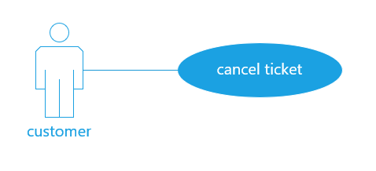
Use case name | Cancel ticket
Unique ID | 009
Area | Website
Actor(s) | Customer
Description | Customer cancel ticket
Triggering Event | customer click “cancel” button in the website
Preconditions | - The customer needs to open website on monitor  - The customer needs to have account
Post conditions | Ticket has canceled
Assumptions | - customer has browser  - A valid data
Steps Performed |  | Information for Steps
- Open website
- Customer log in
- Customer book ticket
- Customer cancel ticket

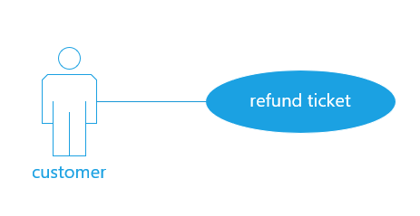

Use case name | Refund ticket
Unique ID | 010
Area | Website
Actor(s) | Customer
Description | Customer refund ticket
Triggering Event | customer click “refund” button in the website
Preconditions | - The customer needs to open website on monitor  - The customer needs to have account
Post conditions | Ticket has refunded
Assumptions | - customer has browser  - A valid data
Steps Performed |  | Information for Steps
- Open website
- Customer log in
- Customer book ticket
- Customer cancel ticket

